- NM-Association of Surgical Technologists  03-23-19 | Spring Seminar:  Rio Rancho
Scrub Life Conference | Online registration is open now for the NM-AST Scrub Life Conference in the Albuquerque Metro area! 0730-1300 with 4 CEUs.  Location  Presbyterian Rust Medical Center  2400 Unser Blvd SE, Rio Rancho, NM 87124  Lower Level Conference Room, next to cafeteria  Agenda  0730-0800 Registration and Light Breakfast  0800-0850 Dr. Andrew Paterson, Topics in Adult Orthopaedic Spine Surgery  0900-0950 Carolyn Sajdecki, CNIM, REEGT, REPT, The Art of Surgical Neuromonitoring  1000-1050 Dr. Maxx Gallegos, Urethral Reconstruction Using Buccal Mucosa Grafts  1100-1130 Lunch  1130-1220 Dr. Ronald Escudero, Facial Plastic Surgery 101  1230-1300 Annual Business and Board Elections  Facebook page https://www.facebook.com/nmastassembly/  Webpage http://nm.ast.org  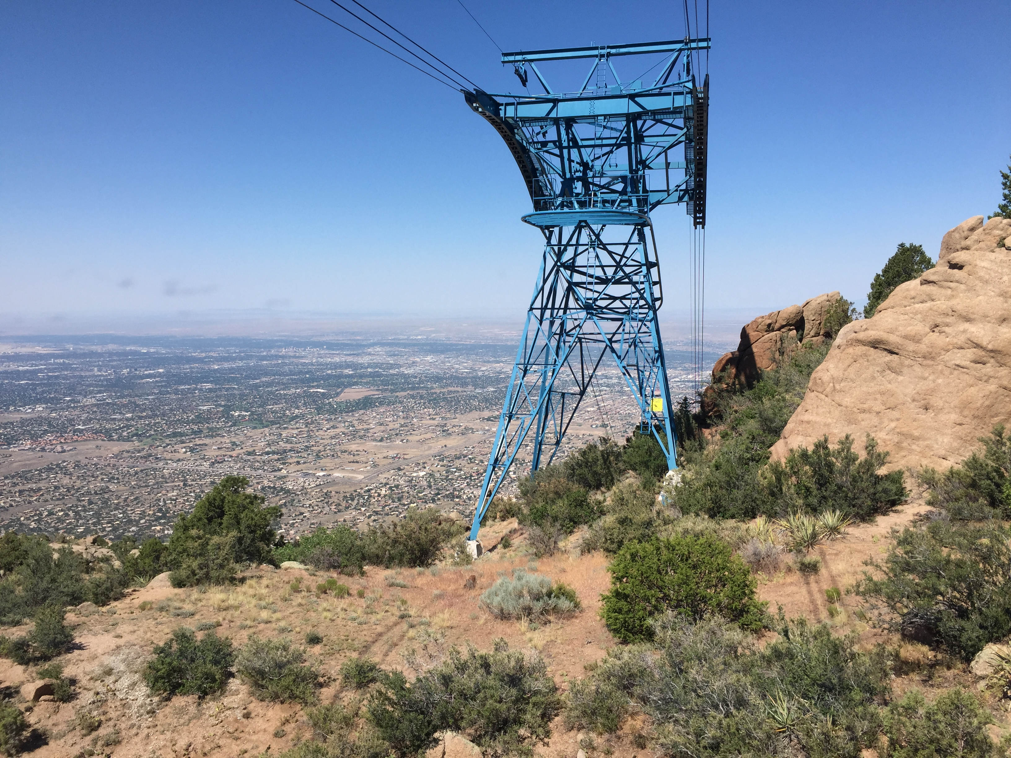

Scrub Life Spring 2019 AST Conference
Date: March 23, 2019 / Time: 0730 to 1300
- 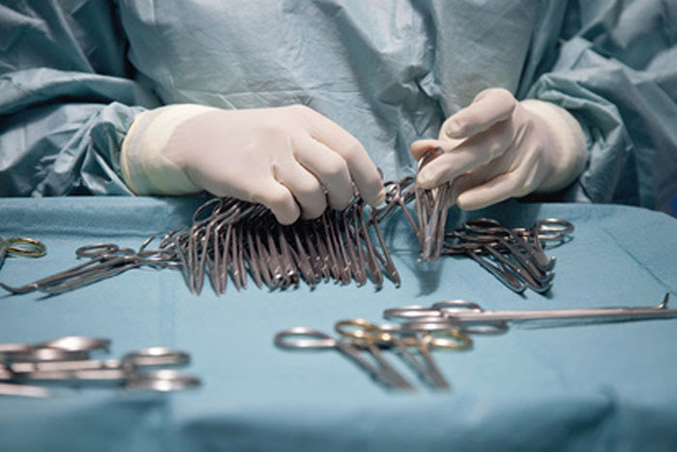
  - 4 CEU
  - 4 Speakers
  - Breakfast burritos and snacks provided
  - Prizes
  - Network
Cost $25 for AST Members, $10 for Students and Guests
- Date March 23, 2019
Time 0730 - 1300
Address Presbyterian Rust Medical Center
2400 Unser Blvd SE, Rio Rancho, NM 87124
Lower Level Conference Room, next to the cafeteria
https://form.jotform.com/90126159998167
Social media promo: First 30 applicants will be automatically entered into a drawing to win free entry to next state conference. Possible winners (3). Winners must be present on the date of the conference to be eligible to win.

